***Conceptual Design:* Batch : B4**

**DESCRIPTION-**

The **aim** of this case study is to design and develop a database for the hospital to maintain the records of various departments, rooms, and doctors in the hospital. It also maintains records of the regular patients, patients admitted in the hospital, the check up of patients done by the doctors and patients discharged from the hospital.

**ENTITY RELATION DIAGRAM-**

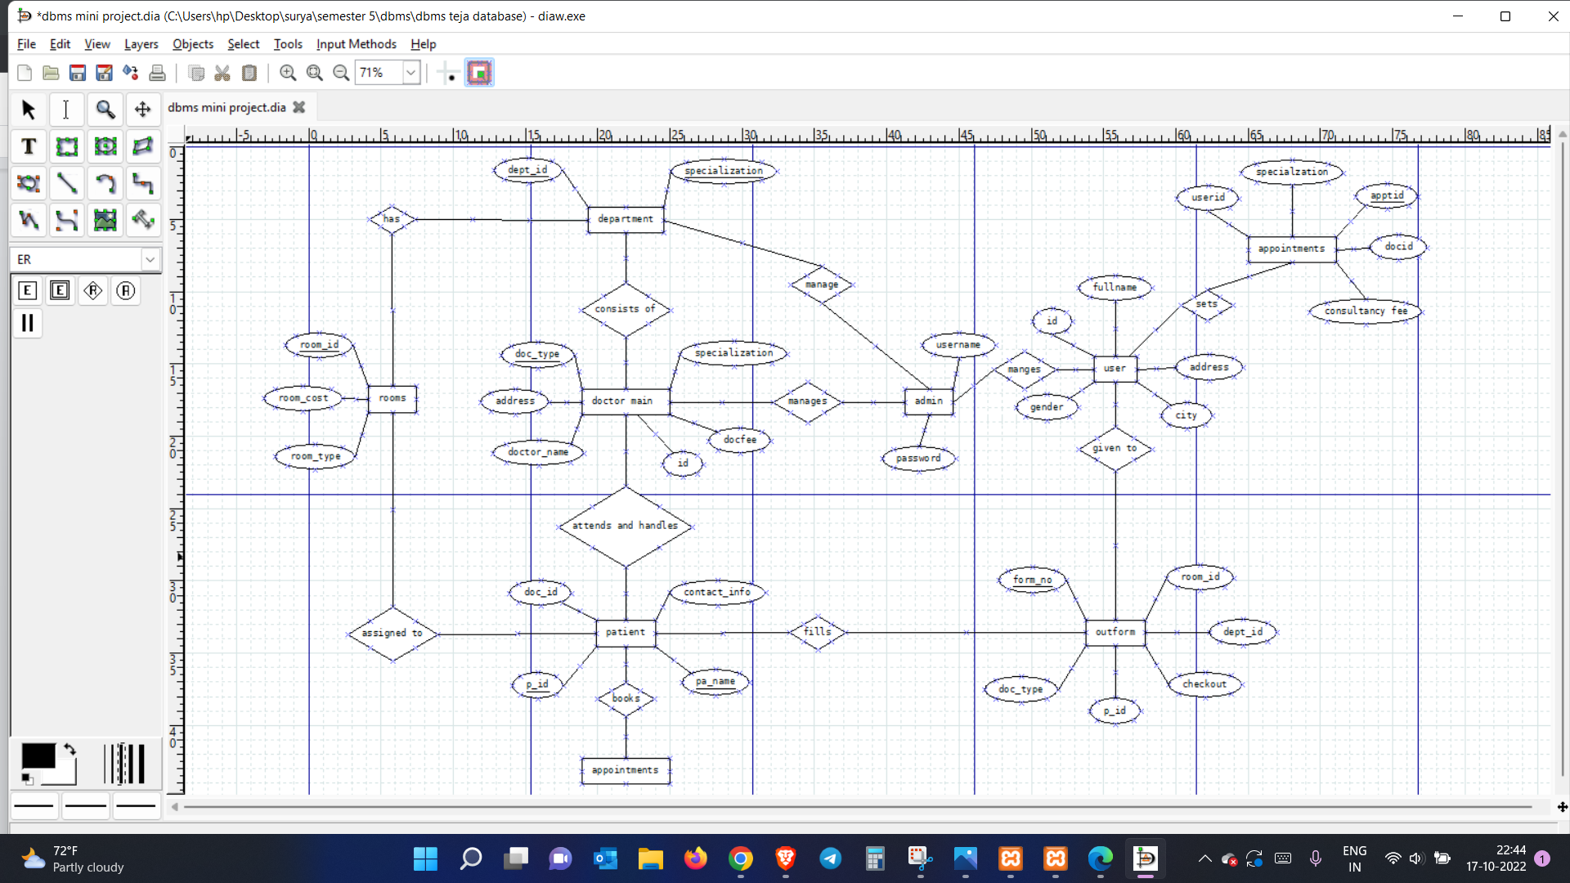

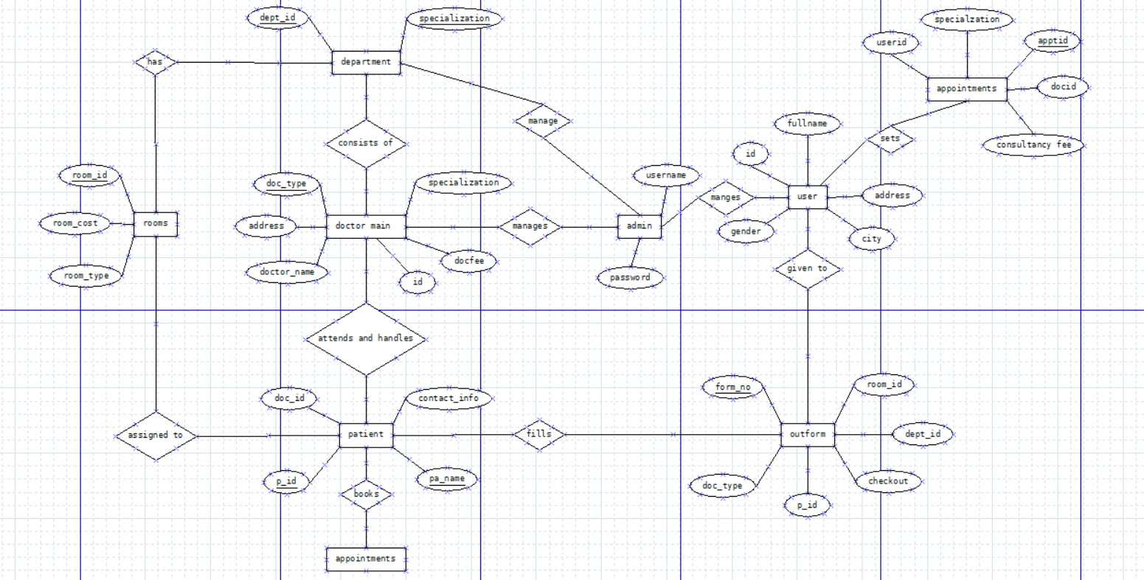

**Conceptual Design-**

**DEPARTMENT-**

TABLE department

(dept_id varchar(70) ,

dept_name varchar(70) ,

PRIMARY KEY(dept_id , specialization)

);

**ROOM-**

TABLE rooms

(room_id varchar(50),

room_type char(50),

room_cost int(50),

PRIMARY KEY (room_id)

);

**appointments-**

TABLE appointments

(userid varchar(50),

apptid varchar(50),

Consultancy fee int(50),

docid varchar(50),

specialization varchar(50),

PRIMARY KEY (apptid)

);

**DOCTOR-**

TABLE doctor

(id varchar(50),

doc_type varchar(50),

doctor_name varchar(50),

address varchar(50),

docfee varchar(50),

specialization varchar(50),

PRIMARY KEY (doc_type),

);

**PATIENTS-**

TABLE patients

(p_id varchar(50),

pa_name varchar(50),

contact_info bigint(100),

doc_id varchar(50),

PRIMARY KEY (p_id,pa_name)

);

**Outform-**

TABLE outform

(form_no varchar(20),

p_id varchar(50),

emp_id varchar(50),

doc_type varchar(50),

dept_id varchar(50),

room_id varchar(50),

checkout date,

PRIMARY KEY (form_no),

FOREIGN KEY (p_id) references patients(p_id),

FOREIGN KEY (emp_id) references employee(emp_id),

FOREIGN KEY (doc_type) references doctor(doc_type),

FOREIGN KEY (dept_id) references department(dept_id),

FOREIGN KEY (room_id) references rooms(room_id)

);

**Admin-**

TABLE admin

(username varchar(50),

password varchar(50),

);

**User-**

TABLE user

(id varchar(50),

fullname varchar(50),

Address varchar(50),

city varchar(50),

gender varchar(50),

);

**PRIMARY KEYS-**

**department -** dept_id , dept_name

**rooms -** room_id

**doctor -** doc_type

**patient** - p_id ,pa_name

**outform** - form_id

**Appointments -** apptid